An OFDM system carries payload data on orthogonal sub-carriers for parallel transmission, combating the distortion caused by the frequency-selective channel. However, the advantages of OFDM can only be realized when orthogonality is maintained. If not, its performance may be degraded due to inter-symbol interference (ISI) and inter-channel interference (ICI). In this article, we analyze the effects of the symbol-time offset (STO) in OFDM systems.

The inverse fast Fourier transform (IFFT) and fast Fourier transform (FFT) are the fundamental functions required for the modulation and demodulation at the transmitter and, respectively. In order to determine the N-point FFT in the receiver, we need the exact samples of the transmitted signal for the OFDM symbol duration. In other words, a symbol-timing synchronization must be performed to detect the starting point of each OFDM symbol.

The following table shows how the STO of δ samples affects the received symbols in the time and frequency domain, where the effects of channel and noise are omitted for simplicity:

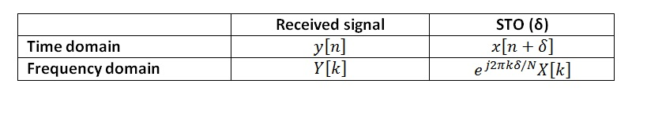

As the table shows, a symbol timing offset of δ samples in the time domain incurs a phase offset, 2πkδ/N, in the frequency domain, which is proportional to the subcarrier index, *k*, as well as the STO, δ.

In general, STO estimation can be implemented in either the time domain or the frequency domain. In the time domain, STO can be estimated by using the cyclic prefix or training symbols.

Estimating STO In The Time Domain By Using The Cyclic Prefix

Consider an OFDM symbol with a cyclic prefix (CP):

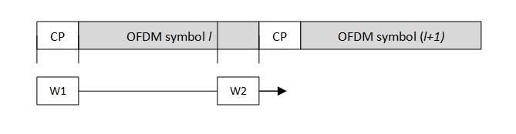

Since a cyclic prefix is a portion of an OFDM symbol that is copied to the front of the same OFDM symbol, there are similarities between the CP and a portion of the OFDM symbol, which can be used for STO estimation.

As shown in the figure above, consider two sliding windows, W1 and W2, which are spaced correctly depending on the length of the OFDM symbol. The similarity between these two windows of Ng samples is maximized when the CP falls into the first sliding window. That is, the similarity is maximized when the difference between these windows is minimized. Mathematically, this concept can be expressed as follows:

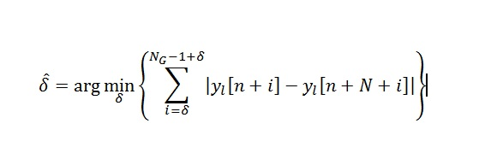

This technique has an advantage in that no extra overhead is needed, since we are using the CP which is already part of most OFDM systems. However, the effect of a multipath channel can degrade the performance of this approach.

Estimating STO In The Frequency Domain By Using A Dedicated Training Symbol

The other approach estimates the STO by using a dedicated training symbol. In contrast with the first method, this one involves overhead in transmitting the training symbol, but it doesn’t suffer from the effects of a multipath channel. The [Nutaq OFDM reference design](https://www.nutaq.com/products/ofdm-reference-design/) uses this approach, by including a single OFDM symbol with a repetitive structure.

Another example is the IEEE 802.11 standard, which uses a short preamble sequence before each burst for time synchronization purposes.

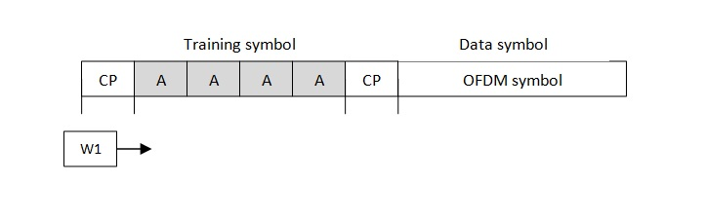

In this standard, the STO estimation is done using the correlation between the training symbol and the received signal, since the training symbol is known to the receiver. In practice, the auto-correlation operation can be easily implemented using a finite impulse response filter (FIR), which is part of many software libraries.

In that case, we use a matched filter approach, which is the best way to detect a signal in the presence of additive white Gaussian noise (AWGN). Due to the repetitive structure of the training symbol, we can use a small FIR filter with a finite number of coefficients equal to the length of one “A” block, instead of using a large FIR filter for the entire training symbol. This concept is useful in field-programmable gate array (FPGA) designs.

This article presents two time domain symbol timing offset estimation techniques. These techniques can be used to detect the boundary of an OFDM symbol, which is crucial for selecting the right samples for the FFT algorithm at the receiver. A good training symbol should have a low peak-to-average power ratio (PAPR), as well as good cross-correlation and auto-correlation characteristics. Well-known preamble sequences for cellular systems include PN sequences, Gold sequences, and CAZAC sequences.